Day 2 lab assignment

Q1)Read the CSV file

Code)

"""

Created on Wed Jan 12 12:35:01 2022

@author: Akanksha N Shenoy

"""

import pandas as pd

dataset = pd.read_csv("Data.csv")

O/p:

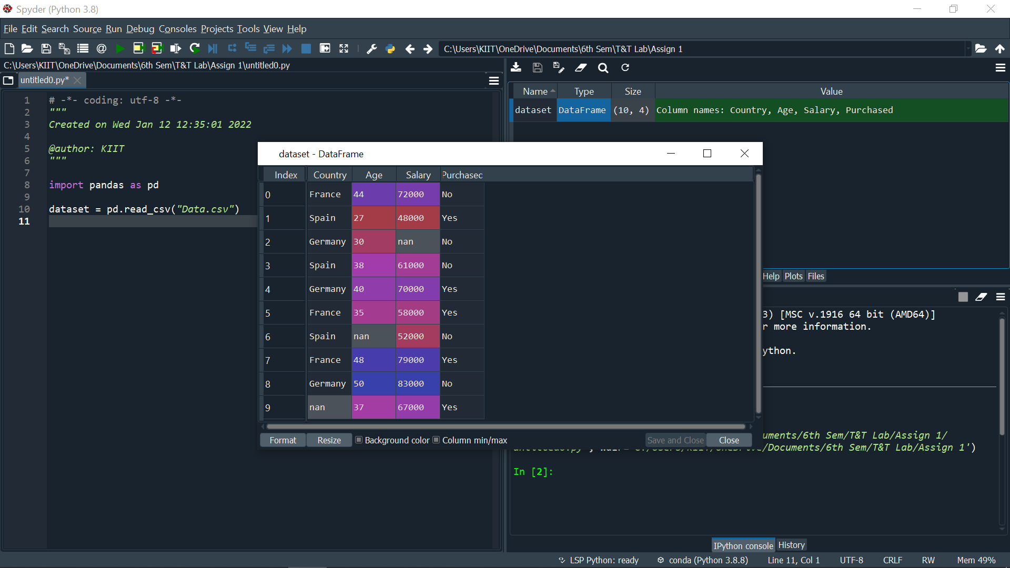

Q2)In the dataset “data.csv”, in google classroom:

i) Add a new column : Salary_class

A for loop is implemented and the observations are

separated into three categories:

o Salary

• greater than 70000 - class0

• between 61000-70000 -class1

• between 48000-60000 -class2

• The classes have been stored in a new column ‘Salary Class’

Code)

"""

Created on Wed Jan 12 12:35:01 2022

@author: Akanksha N Shenoy

"""

import pandas as pd

dataset = pd.read_csv("Data.csv")

sal_class = []

for sal_data in dataset['Salary']:

if sal_data >= 70000:

sal_class.append("Class 0")

elif sal_data >= 60000:

sal_class.append("Class 1")

elif sal_data >= 4800:

sal_class.append("Class 2")

else:

sal_class.append("")

dataset["Salary_Class"] = sal_class

print(dataset)

O/p)

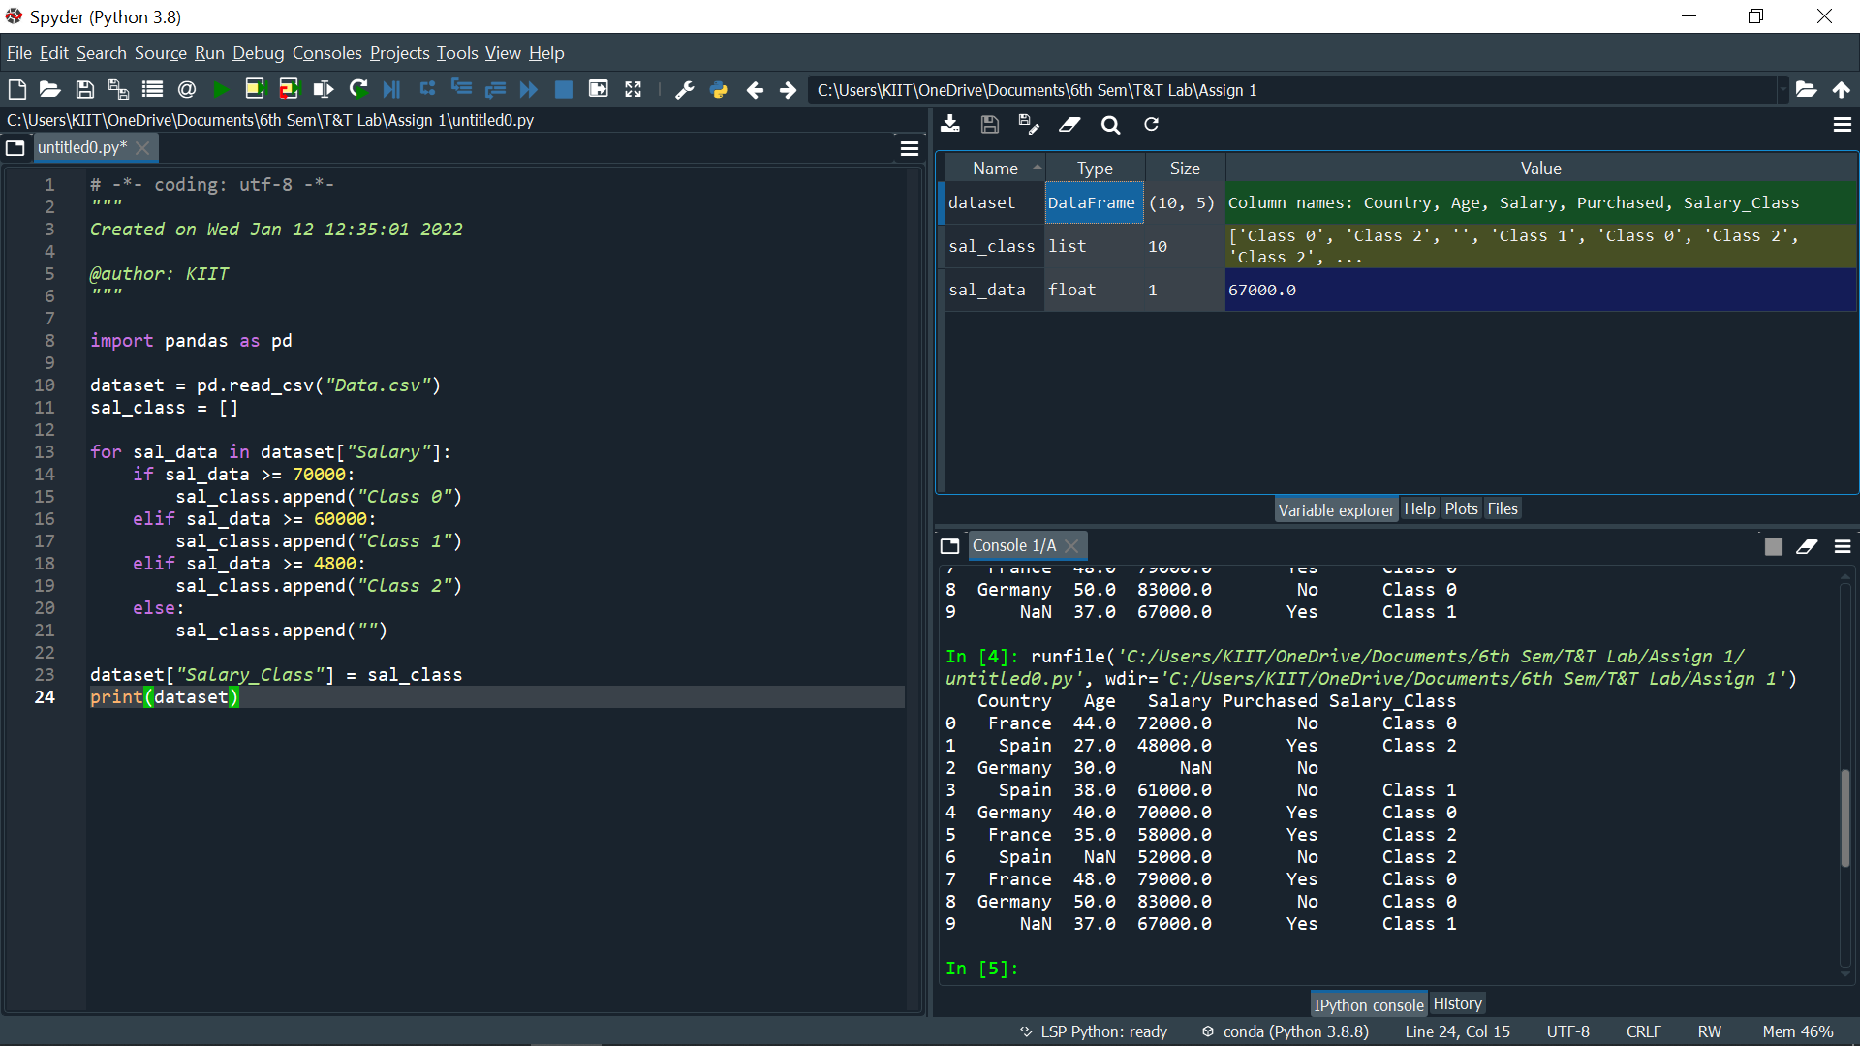

Q3)Implement above using both for and while loop

Code)

"""

Created on Wed Jan 12 12:35:01 2022

@author: Akanksha N Shenoy

"""

import pandas as pd

dataset = pd.read_csv("Data.csv")

sal_class = []

i = 0

while i < 10:

sal_data = dataset['Salary'][i]

if sal_data >= 70000:

sal_class.append("Class 0")

elif sal_data >= 60000:

sal_class.append("Class 1")

elif sal_data >= 4800:

sal_class.append("Class 2")

else:

sal_class.append("")

i += 1

dataset["Salary_Class"] = sal_class

print(dataset)

O/p)

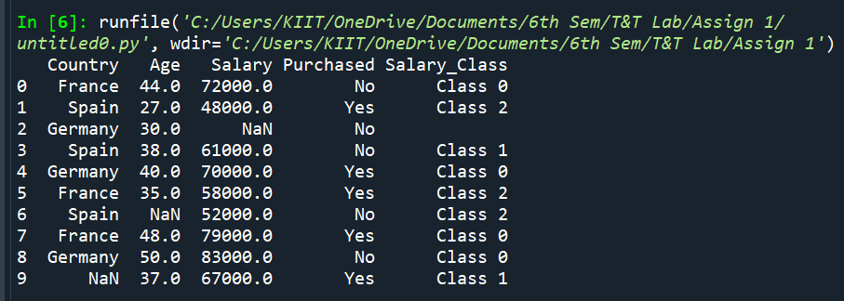

Q4) Count the number of each class (class 0, class1,class2) in your

dataset.

Code)

"""

Created on Wed Jan 12 12:35:01 2022

@author: Akanksha N Shenoy

"""

import pandas as pd

dataset = pd.read_csv("Data.csv")

sal_class = []

i = 0

while i < 10:

sal_data = dataset['Salary'][i]

if sal_data >= 70000:

sal_class.append("Class 0")

elif sal_data >= 60000:

sal_class.append("Class 1")

elif sal_data >= 4800:

sal_class.append("Class 2")

else:

sal_class.append("")

i += 1

dataset["Salary_Class"] = sal_class

#print(dataset)

c0 = len(dataset[dataset['Salary_Class'] == 'Class 0'])

c1 = len(dataset[dataset['Salary_Class'] == 'Class 1'])

c2 = len(dataset[dataset['Salary_Class'] == 'Class 2'])

print(f'Class 0 = {c0} , Class 1 = {c1} ,Class 2 = {c2}')

O/p)

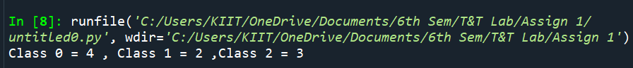

Q5) Insert a new column Age_Converted:

Use function c_convert to add in the new column the converted values

fromcolumn “Age” :

dataset[“Age_Converted”]=dataset[“Age”]*12

Code)

# -*- coding: utf-8 -*-

"""

Created on Wed Jan 12 12:35:01 2022

@author: Akanksha N Shenoy

"""

import pandas as pd

dataset = pd.read_csv("Data.csv")

sal_class = []

i = 0

while i < 10:

sal_data = dataset['Salary'][i]

if sal_data >= 70000:

sal_class.append("Class 0")

elif sal_data >= 60000:

sal_class.append("Class 1")

elif sal_data >= 4800:

sal_class.append("Class 2")

else:

sal_class.append("")

i += 1

dataset["Salary_Class"] = sal_class

#print(dataset)

c0 = len(dataset[dataset['Salary_Class'] == 'Class 0'])

c1 = len(dataset[dataset['Salary_Class'] == 'Class 1'])

c2 = len(dataset[dataset['Salary_Class'] == 'Class 2'])

print(f'Class 0 = {c0} , Class 1 = {c1} ,Class 2 = {c2}')

monthwise_age = dataset['Age']*12

dataset['Age_converted'] = monthwise_age

print(dataset)

O/p)

